|  |  |  |  |  |  |
| --- | --- | --- | --- | --- | --- |
| Date | 6-Dec-22 | | | Tester Name | Mohammad Yusuf |
| Environment | Penfax - Test | | | Login used |  |
| Operating System | Windows | Version: | Update: | | |
| Software Used | Select Software | Version: | Update: | | |
| Select Software | Version: | Update: | | |
| Release version |  | | | | |
| Title |  | | | | |
| Test Type | Regression | | | | |
| Test Scenario |  | | | | |
|  |  | | | | |
| Expected Results |  | | | | |
| Pass/Fail | Select | | | JIRA# | N/A |

Describe your steps with screenshots:

Go to the Benefit Event Search. Select the member. Click on Add Benefit Event

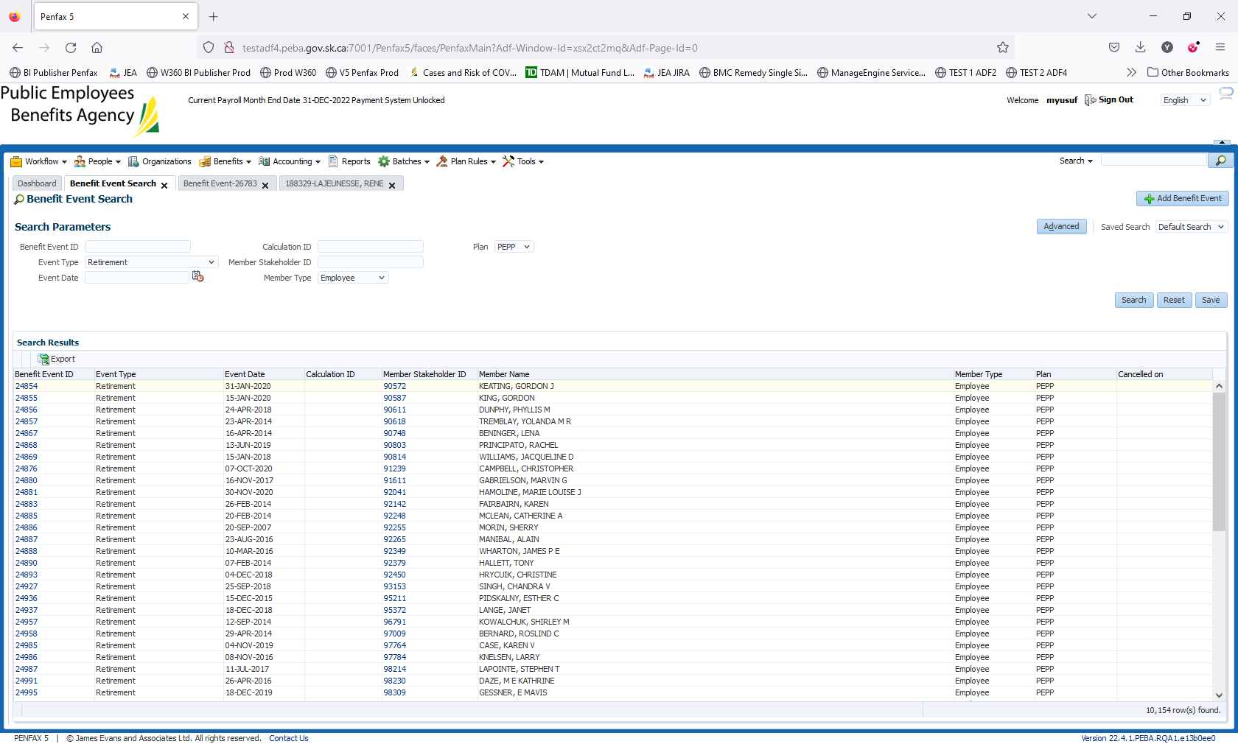

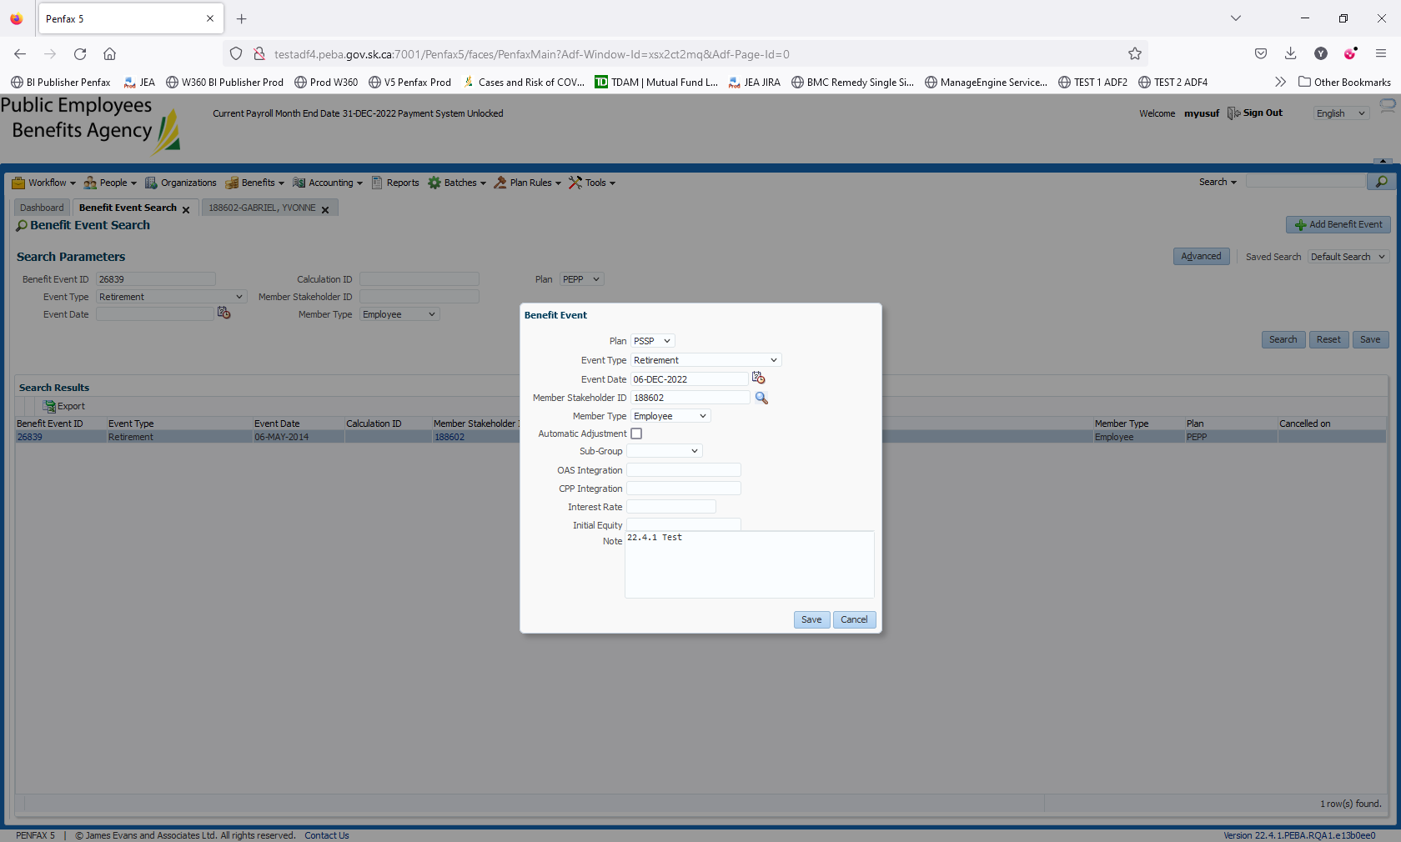

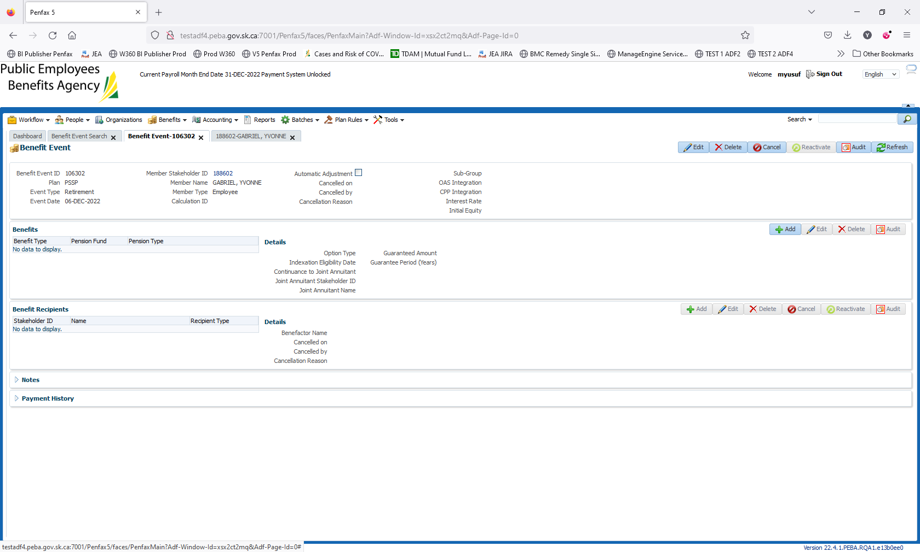

Go to the Benefits -> Click on Add

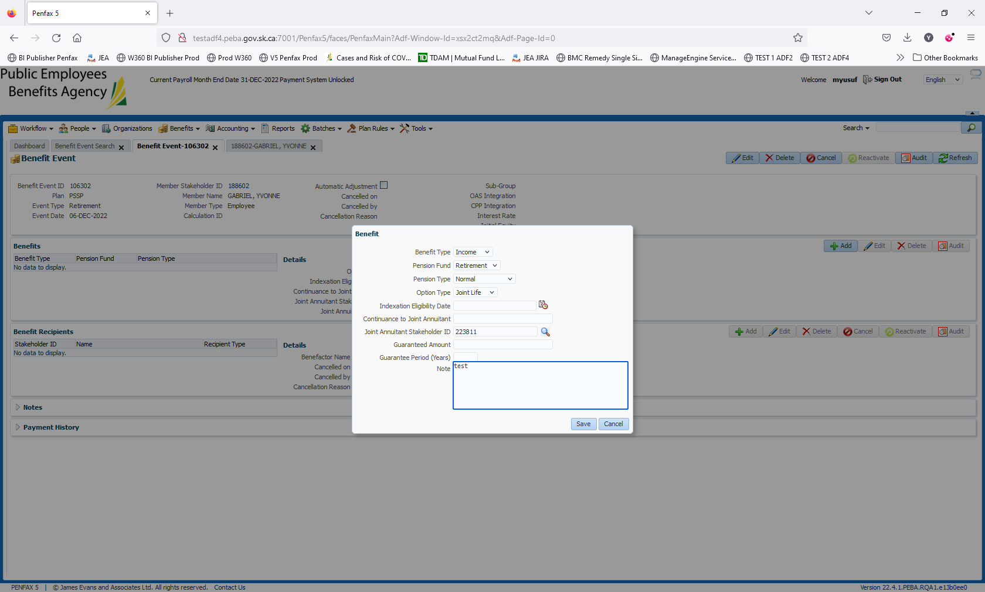

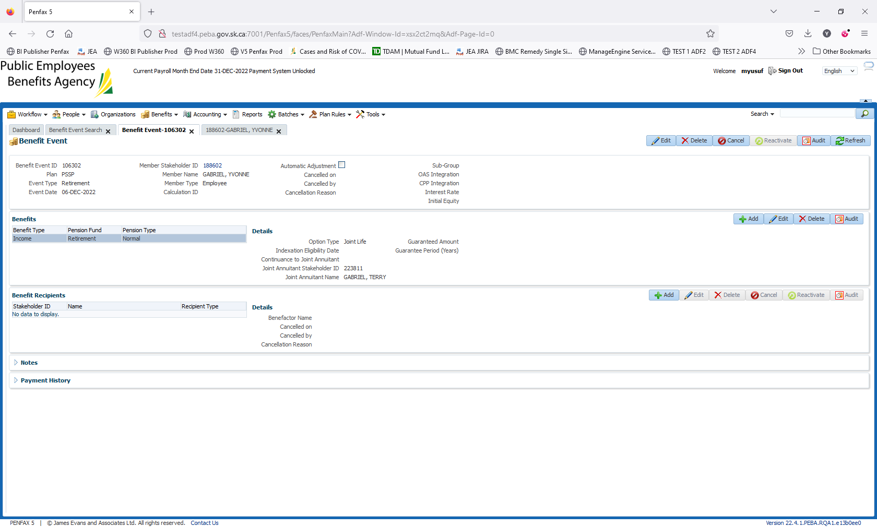

Option Type should be Joint Life. Click on Save

Benefit recipients -> click on add

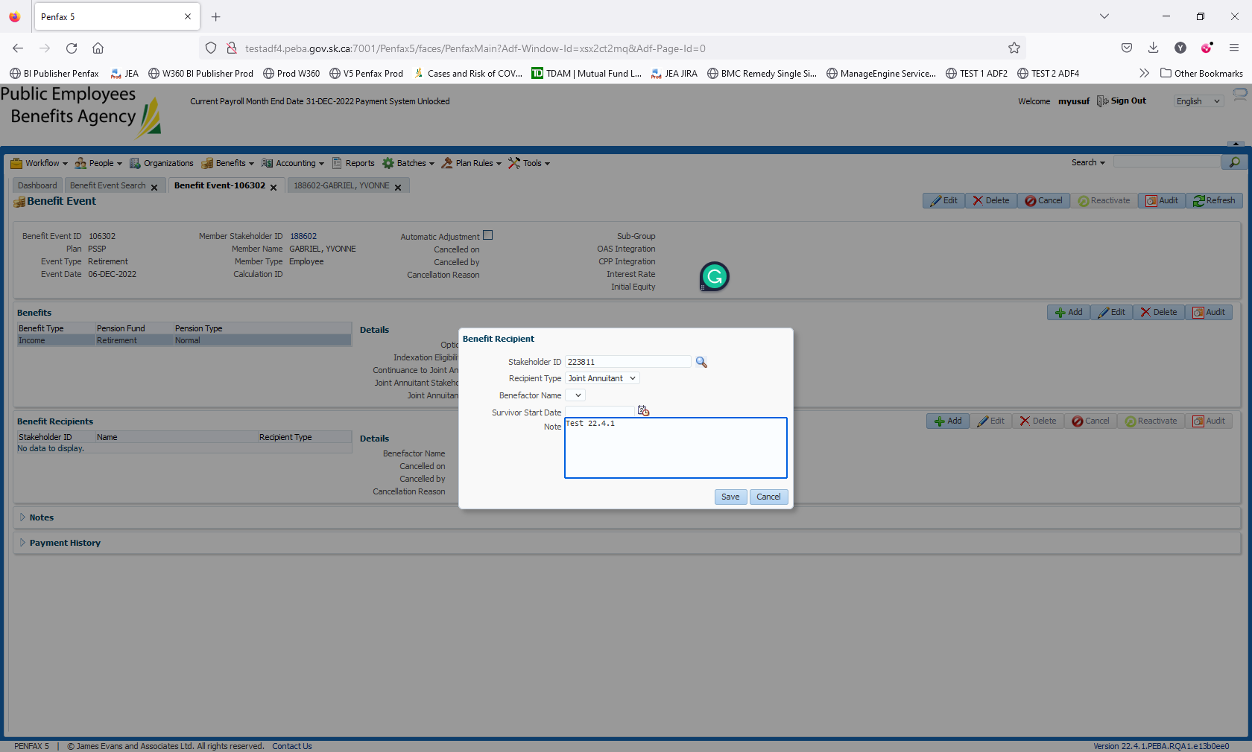

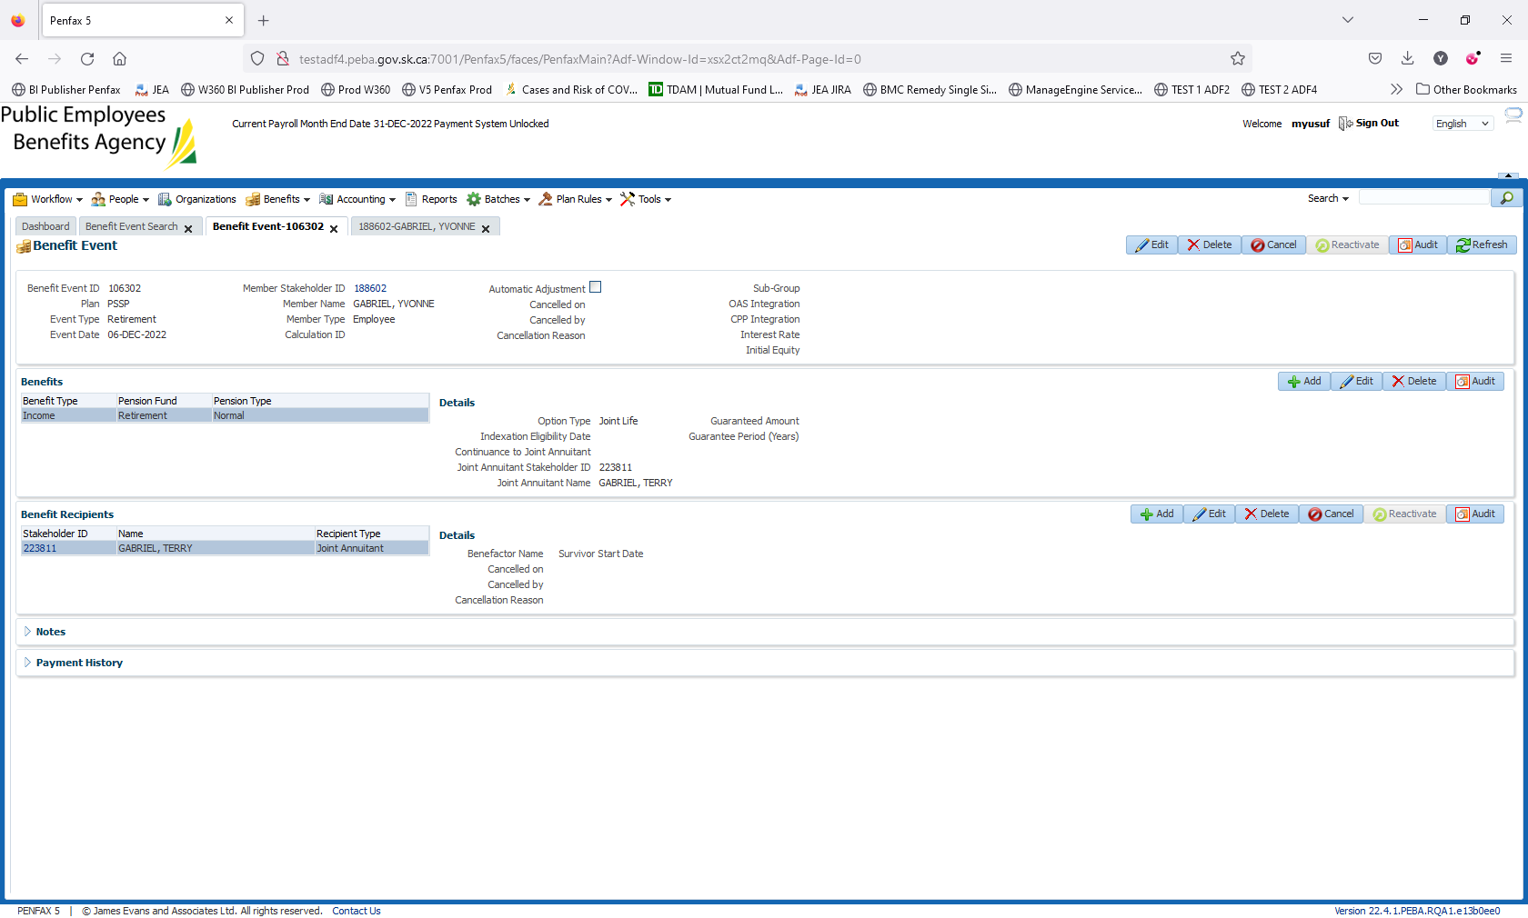

Click on Save

Go to Members Profile 223811. Go to Benefit Recipient -> Income Benefit. Click on add

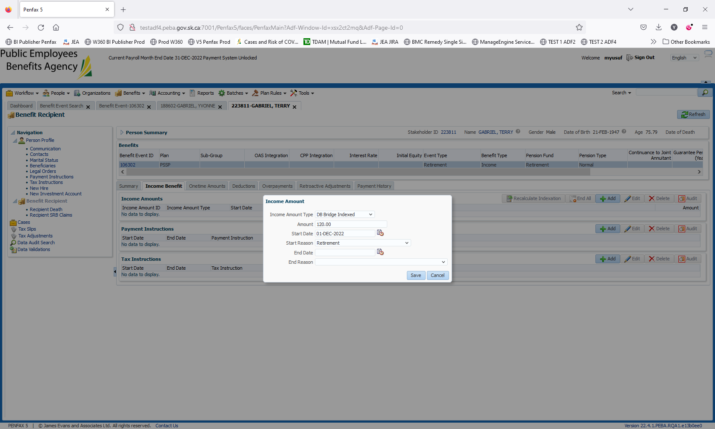

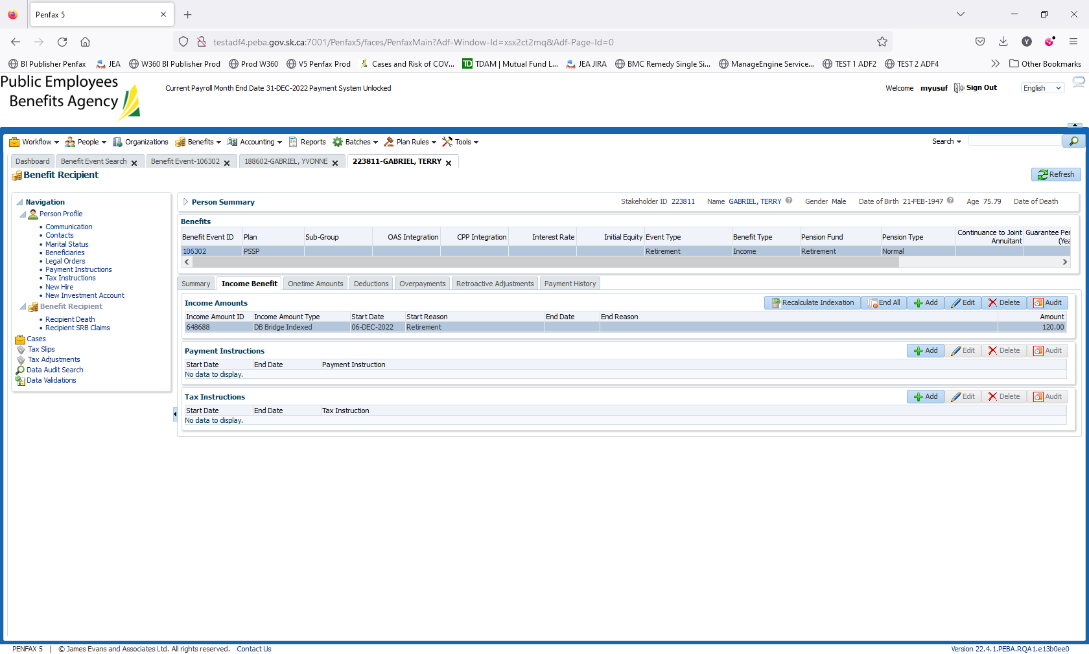

Add Payment and Tax instructions

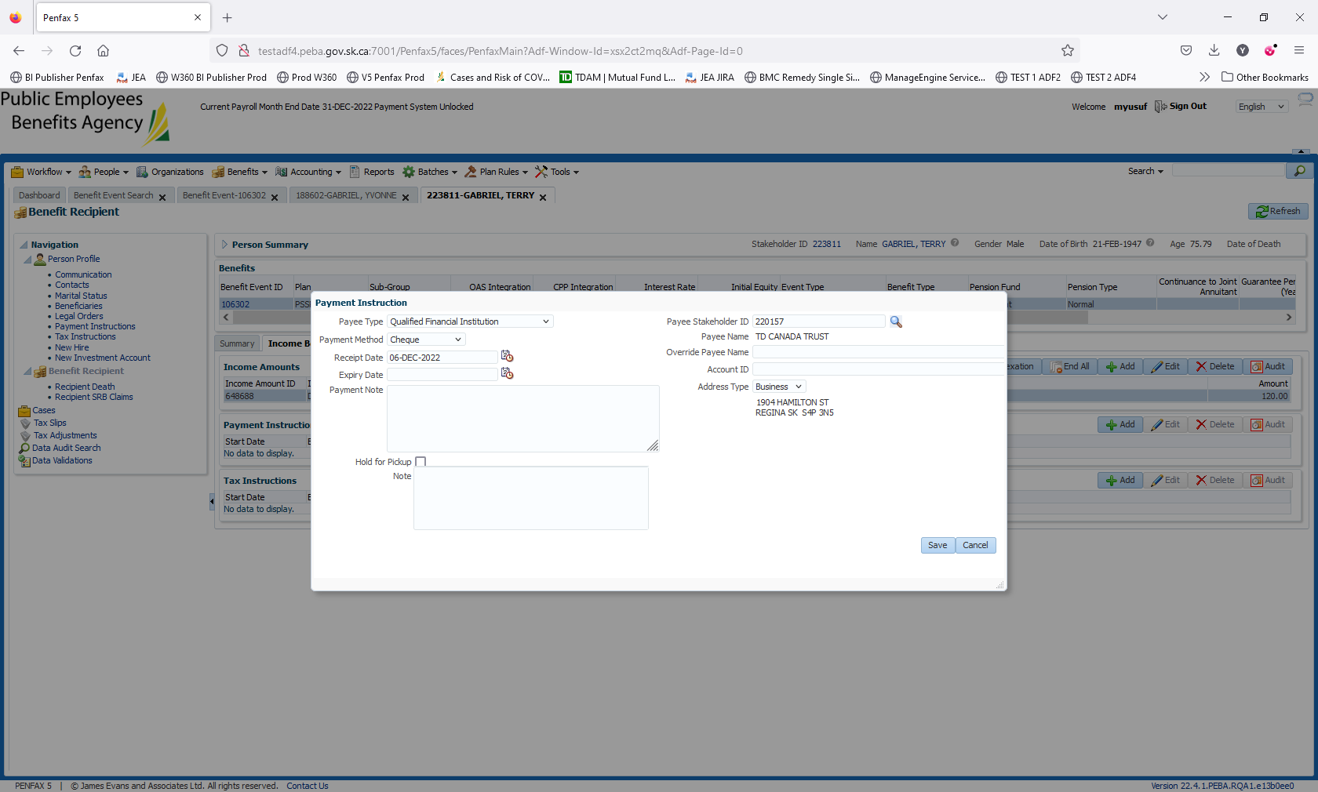

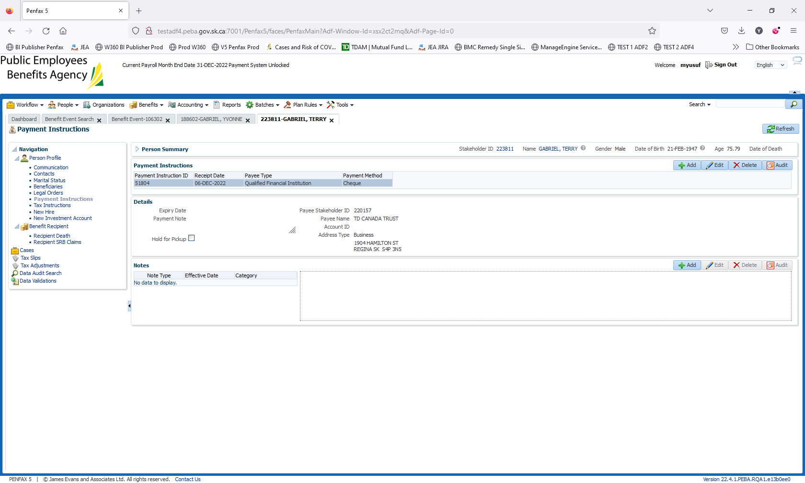

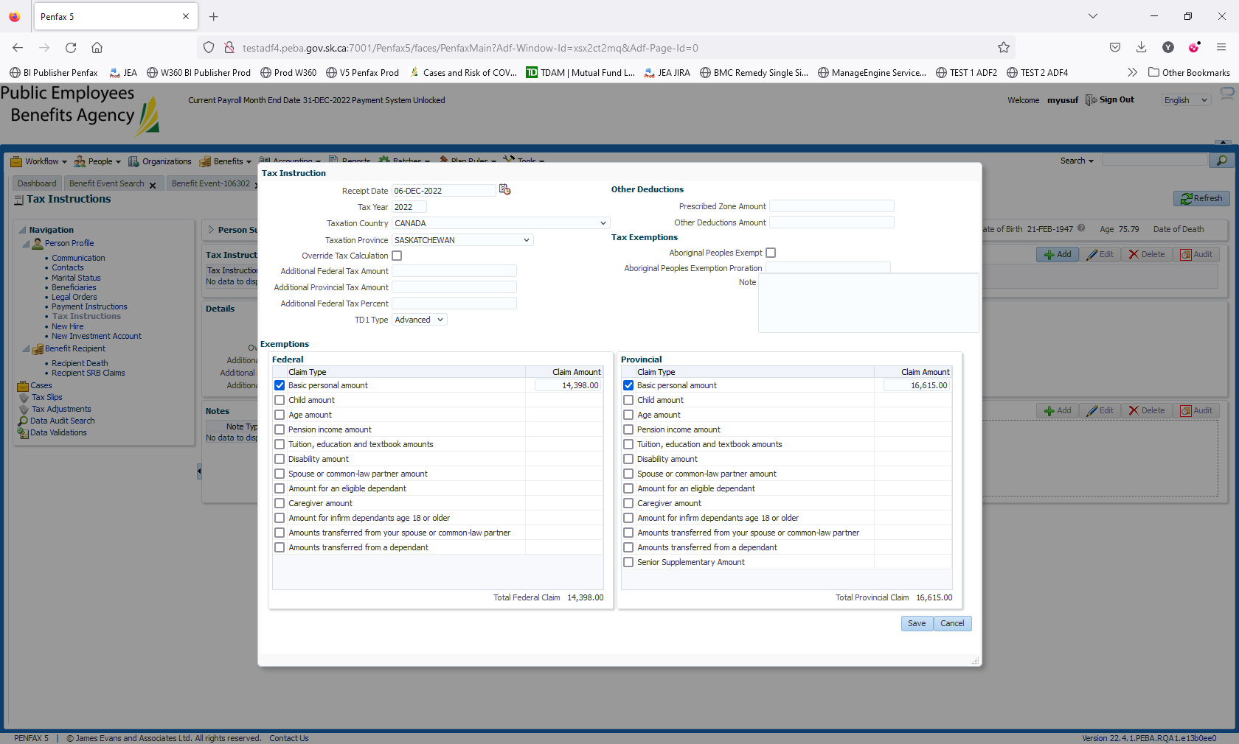

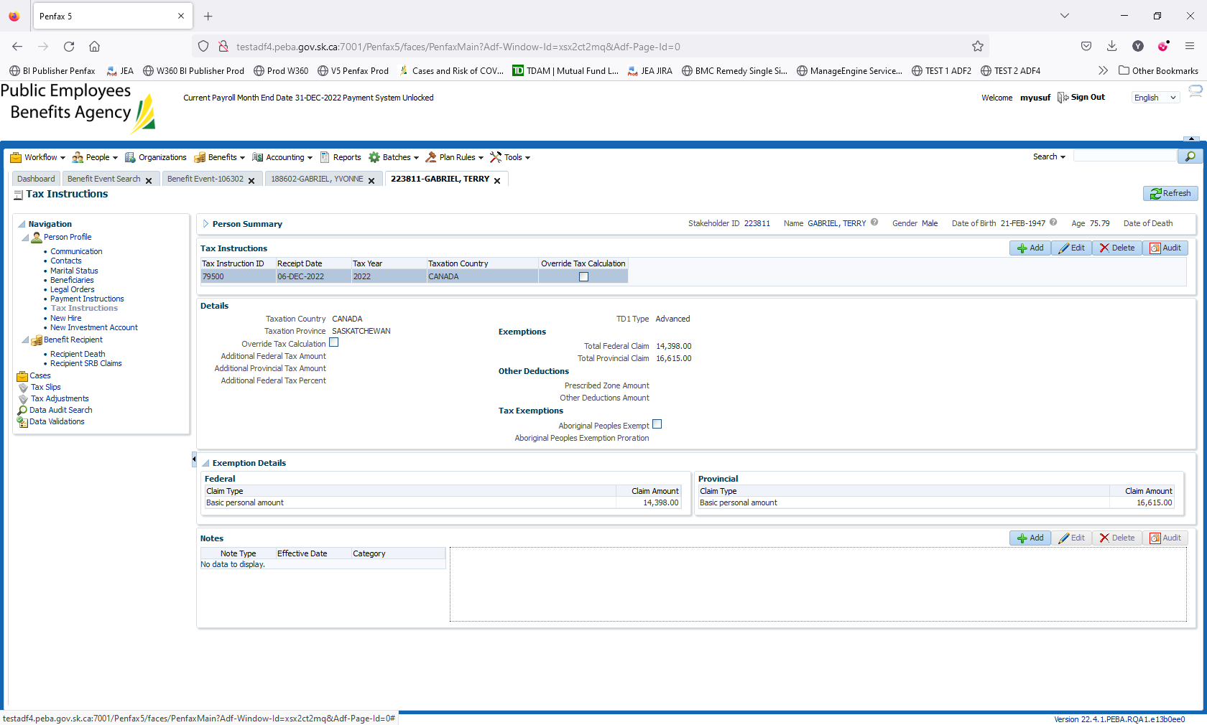

Go to Summary, Authorize the payments for the member

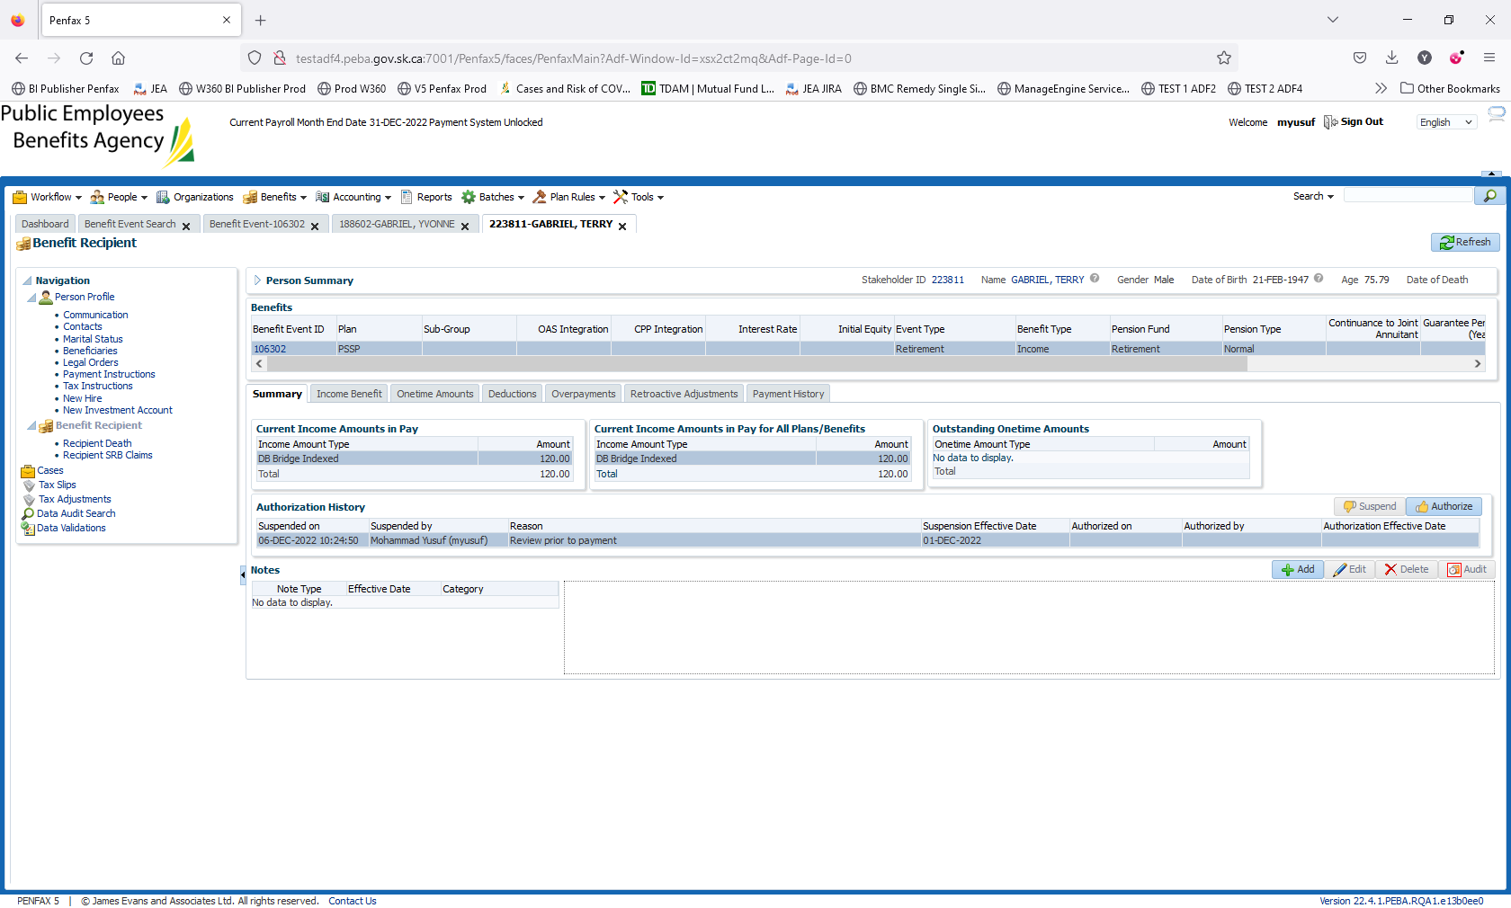

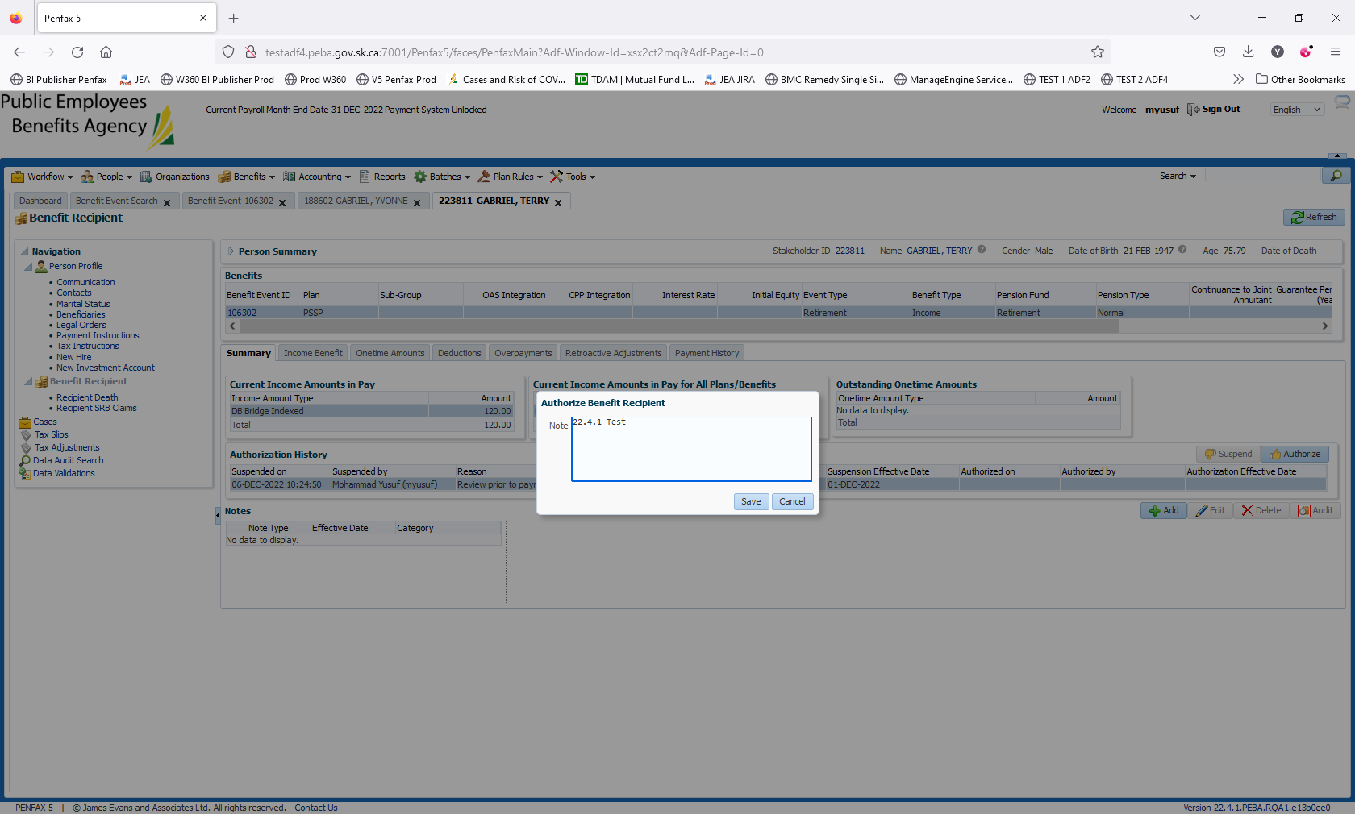

Click on Authorize

